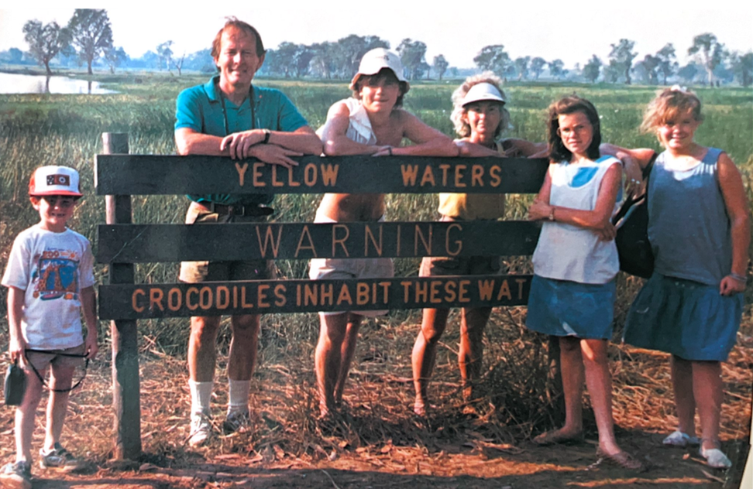

Caption: The Alexander family in 1987, during their six-month adventure in Australia, after Lamar’s governorship ended.

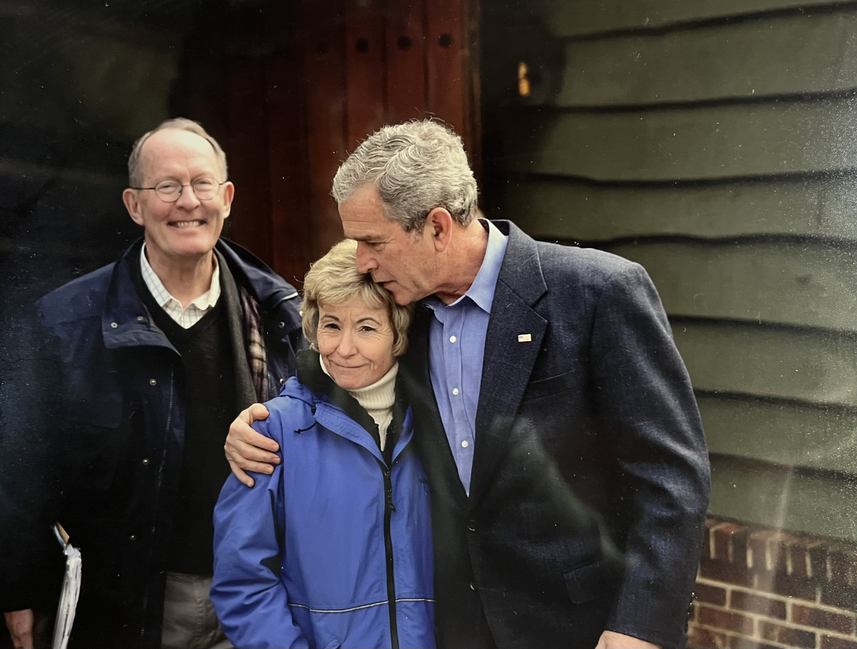

Caption: Lamar and Honey Alexander with George W. Bush at Camp David in 2007.

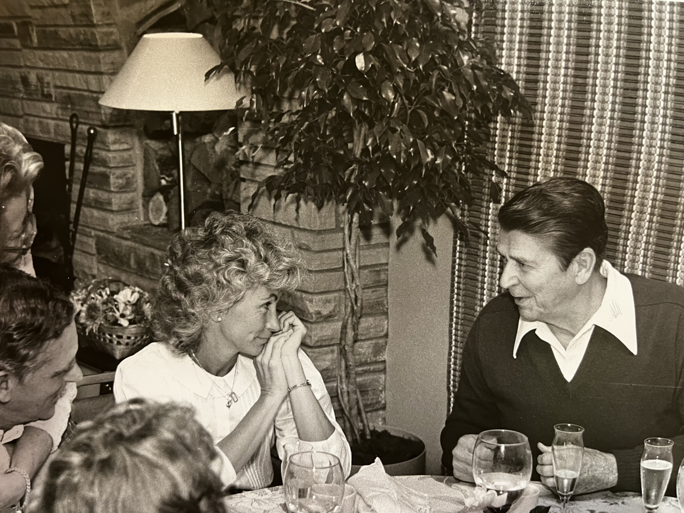

Caption: Honey Alexander and President Reagan in 1982 at Howard Baker’s residence, where Reagan had dinner during a visit to the World Fair’s in Knoxville.

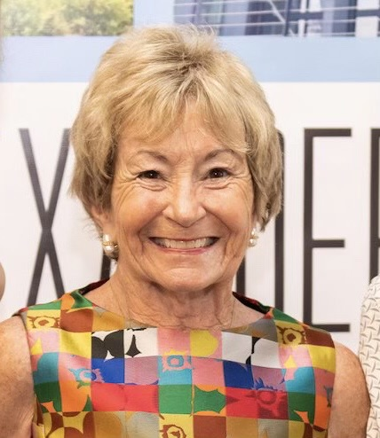

Caption: Honey Alexander at the 2019 opening of the Honey Alexander Center at Nashville nonprofit Family and Children's Service.

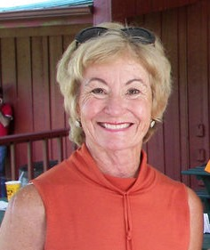

Caption: Honey Alexander